# BBT 1201

# Lab work

# Assignment one codes

Part 1:

Check if a number even

Write this program and run it

Take note on the use of the function isEven()

Do you have any questions?

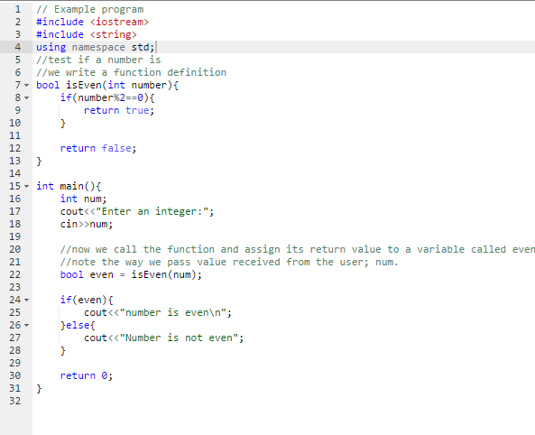

What if a person enters a character and not an integer?

You code should be able to take care of that

See what we add to the above code

It f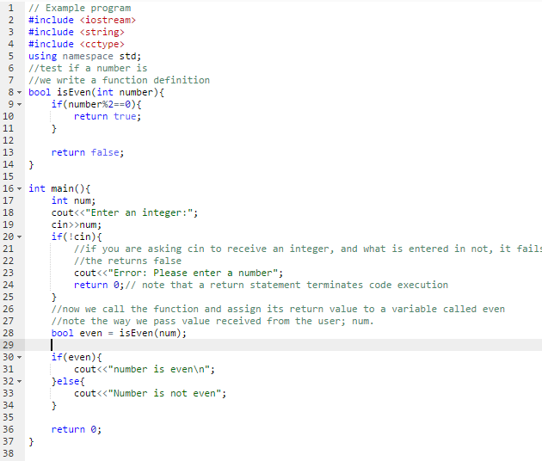

What have we changed in the code?

What is the use of ! in the line 20 of the above code?

What is the effect of the keyword return in a program?

Write a complete C++ program to accept a sentence of over 4 words, then prints the sentence

***Hint***: include the string directive #include <string> and make use of the ***getline*** function

# The switch….case and do….while the ATM example

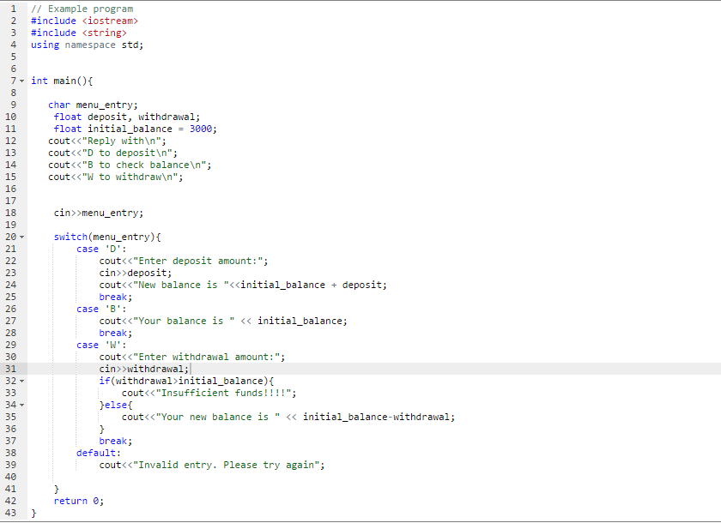

This program has to be restarted every time a one transaction is complete

Now we will add a do…while loop to enable a user complete as many transactions before the program terminates

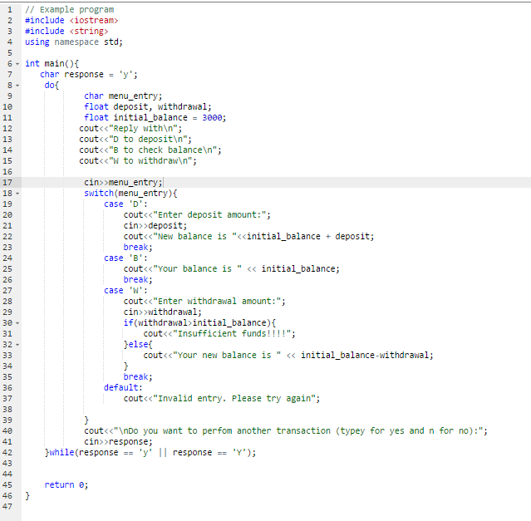

What have changed/added in the code?

What is the effect of putting the code in the line 7 within the do…while loop?

Clearly explain what is happening in line 42. In your description, include the role of double strokes (||) in the code. (The ‘||’ are called ‘pipes’)

Part 2:

Write a simple C++ program that take an integer (decimal) and converts it to binary. You binary number should use 32 bits.

**This lab is complete**